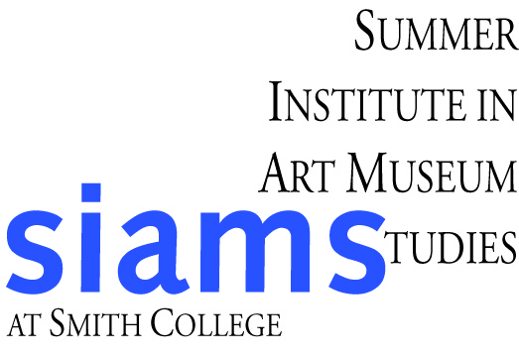

Summer Institute in Art Museum Studies

Financial Aid Application

Complete applications must be received at Smith by March 9, 2012.
Please submit completed form with a copy of the first page of BOTH your own and your parents/ or persons responsible most recent Federal income tax return (with social security numbers marked out). Please provide your most recent college financial aid award letter. Brown SIAMS Fellowship applicants must also complete the Brown Application.

Personal Information

Name (last, first, middle):

Please provide the following information (which will be treated confidentially):

Household Information of Parent(s) or Person Responsible: List all persons living in your household in 2011-2012. Include anyone dependent on you for support or anyone who shares the support of the household.
Full Name | Age | Relationship | If school age, name of school attending

Your total 2010 income: | Value of parent’s savings and investments:
Total income of applicant:
Value of this applicant’s saving and investments:

To Parent(s) or Person Responsible and Applicant: Please provide the following information:

We can contribute a total of $ toward the cost of the 2012 Smith Summer Institute in the Art Museum Studies. We agree that the above statements are true to the best of our knowledge.

My signature below indicates that all the information contained in this application is factually correct and honestly presented.

Applicant Signature: | Date:
Parent/Person Responsible Signature: | Date:

